Example 1: Misleading Bar Chart (Y-axis not starting from zero)

Original (Junk Chart)

Problem: The y-axis starts at 100 instead of 0, which exaggerates differences between categories.

Image:

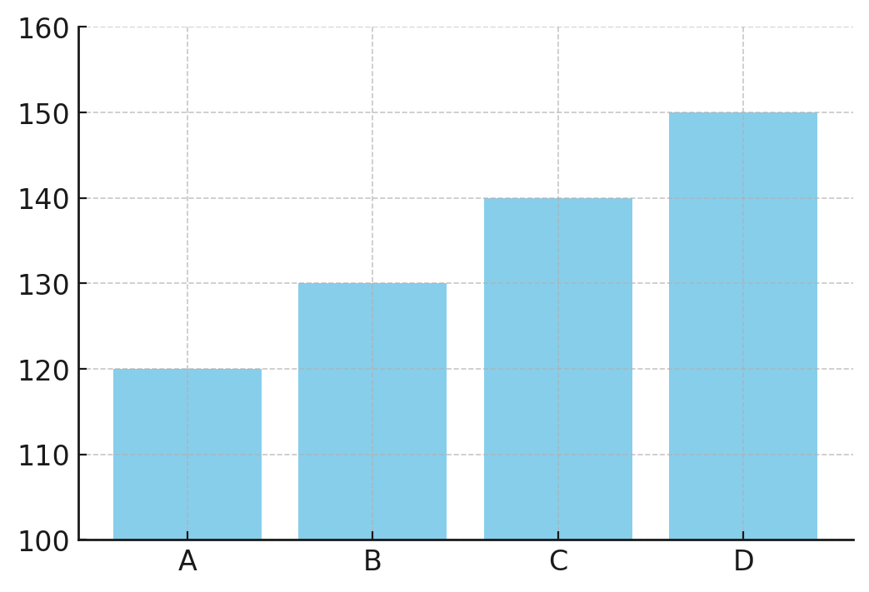

Improved Version

Fix: Start the y-axis at 0 to show the real differences.

Image:

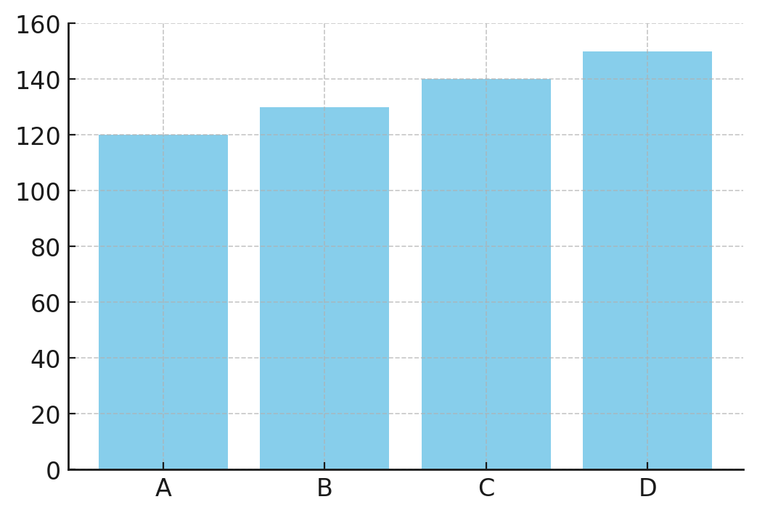

Example 2: 3D Pie Chart

Original (Junk Chart)

Problem: The 3D effect distorts proportions, making some slices look larger than they really are.

Image:

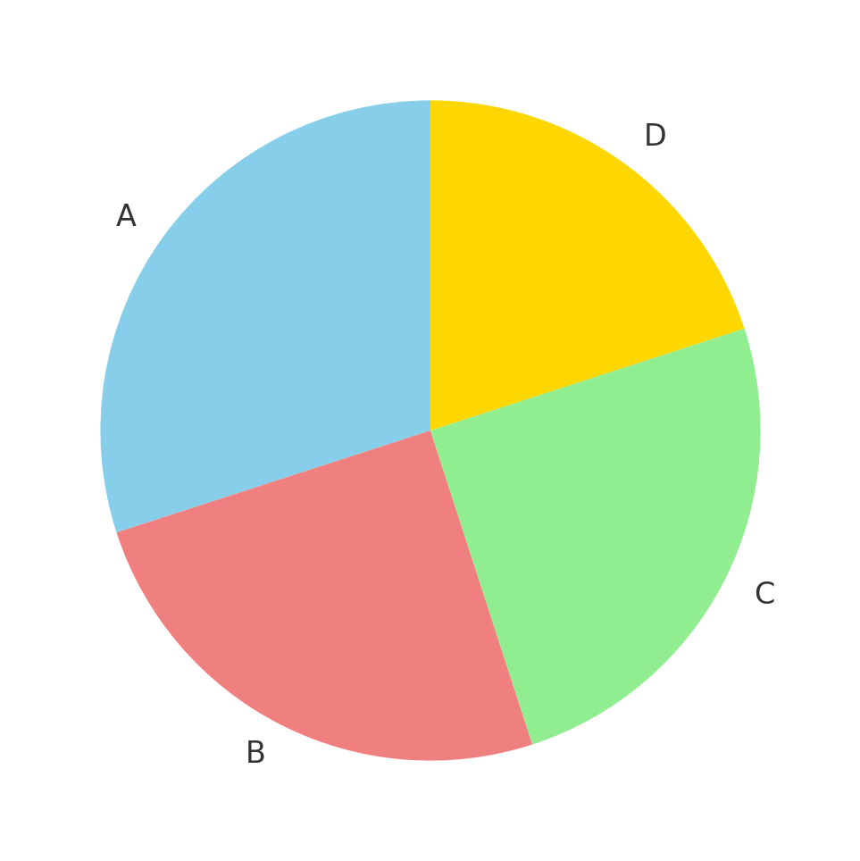

Improved Version

Fix: Replace with a 2D bar chart for easier and more accurate comparison.

Image:

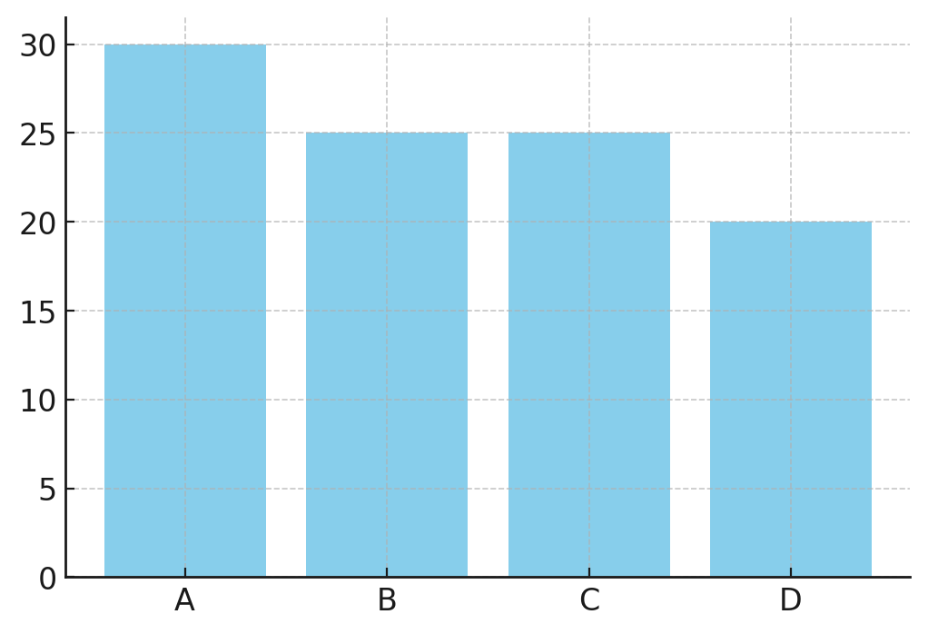

Example 3: Overly Complex Stacked Chart

Original (Junk Chart)

Problem: Too many colors and stacking makes it hard to compare values across groups.

Image:

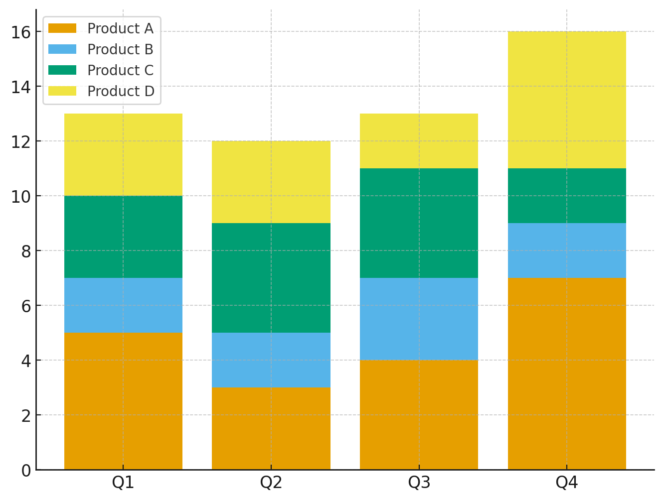

Improved Version

Fix: Use a grouped bar chart so that values are shown side by side, which makes comparison clearer.

Image:

